Day3 Admin Linux

List the user commands and redirect the output to /tmp/commands.list?

If we need to show the history of commands that user entered we can use command history.
And to redirect the output to tmpcommands.list you can use this command
history>>tmp/commands.list

Edit in your profile to display date at login and change your prompt permanently?
To open profile file you can use this command
vi ~/.profile
then you can add this line to display date
echo “date: $(date)”
to change prompt you can do this by changing .bashrcfile

What is the command to count the word in a file or number of file in directory?
To count the words in a file you can use wc -w command

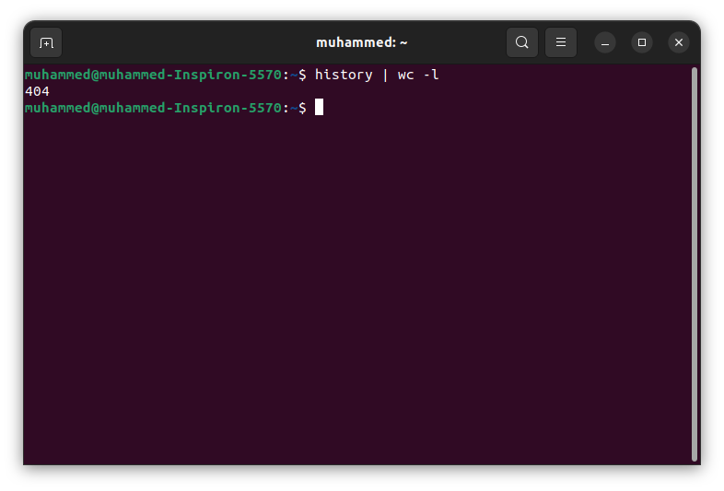

When you execute:
cat file1 | cat file2
the terminal will show the content of file2 only.
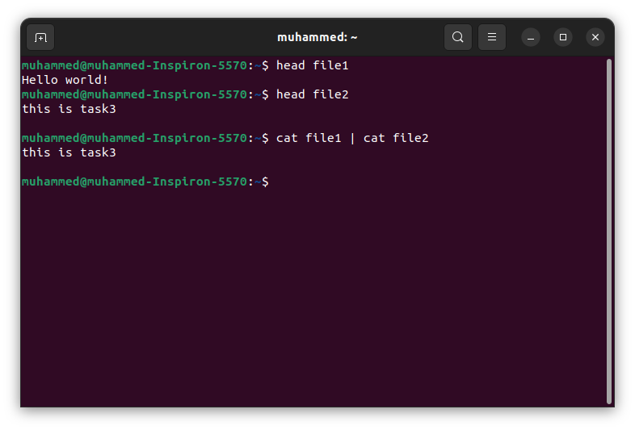
ls | rm
this command will remove all files that is with name ls

ls /etc/passwd | wc –l
this will list the content of passwd file then count lines in this output.

Write a command to search for all files on the system that, its name is “.profile”?
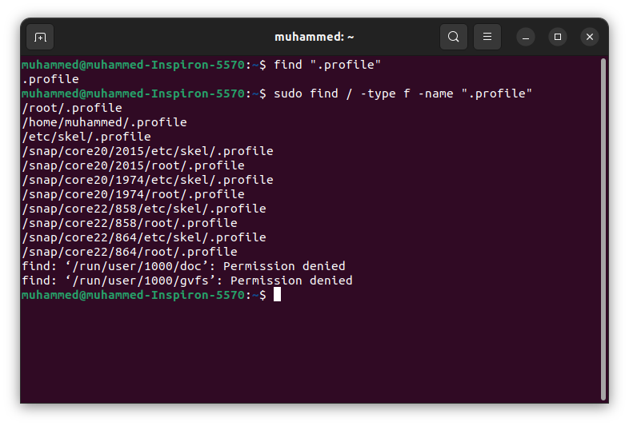
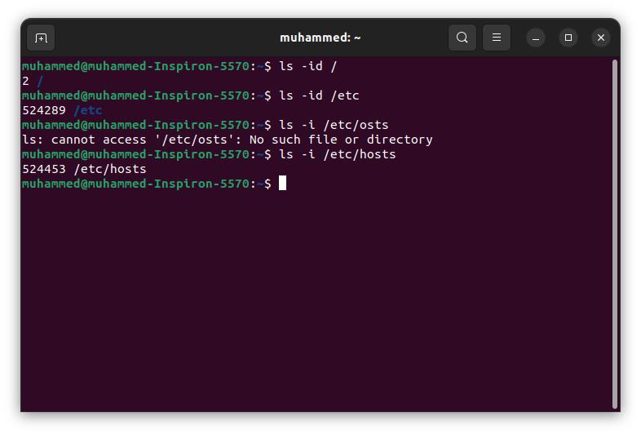
List the inode numbers of /, /etc, /etc/hosts?

Create a symbolic link of /etc/passwd in boot ?
sudo ln -s /etc/passwd /boot/passwd_link

Create a hard link of /etc/passwd in /boot. Could you? Why?
No, hard copy does not work with file system files.

Echo \ it will jump to the next line, and will print >
Notice the prompt ”>” what is that? and how can you change it from “>” to “:”?
